Before choosing a dbms

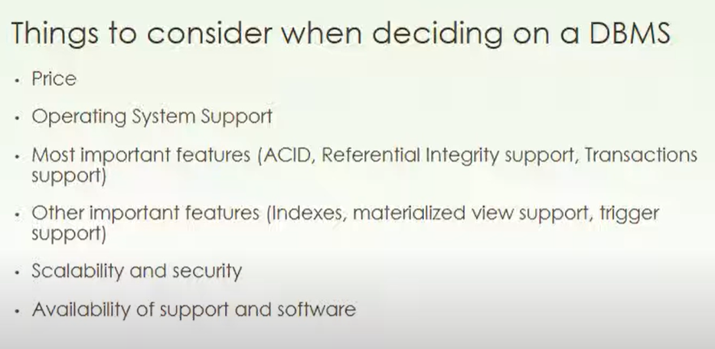

Oracle

Not opensource

Limited features in free version

Extensive backup

Mysql & postgress

🡪Open source

🡪Os:- linux commonly used.

🡪lack acid properties comparatively

**Difference between mysql vs postgress-sql vs oracle**

